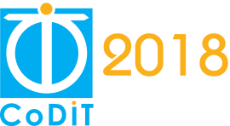
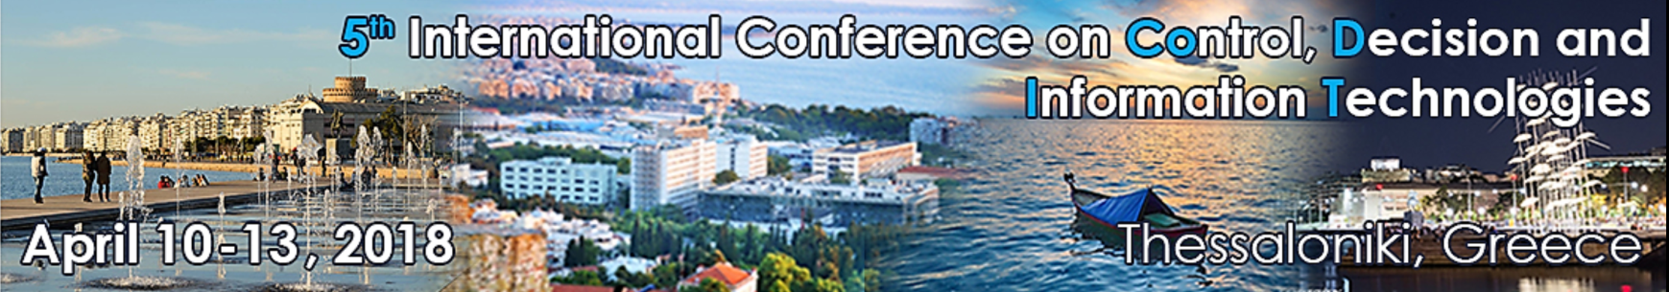

CALL FOR PAPERS
SPECIAL SESSION ON
“Special Session Title”
for CODIT’18
April 10-13, 2018 – Thessaloniki, Greece

Session Co-Chairs :
Prof. Maria Pia Fanti, Polytechnic of Bari, Italy
Prof. Nicholas Karampetakis, Aristotle University of Thessaloniki, Greece
Prof. Enrique H. Viedma, University of Granada, Spain

Session description
This special session deals with the problem of ………………………………………………………………………………………… …………………………………………………………………………………………………………………………………………………………………………………………………………………………………………………………………………………………………………
The goal is to…………………………………………………………………………………………………………………………………………… …………………………………………………………………………………………………………………………………………………………………………………………………………………………………………………………………………………………………………
The topics of interest include, but are not limited to:
- …
- …
- …

SUBMISSION
Papers must be submitted electronically for peer review through PaperCept by December 10, 2017: http://controls.papercept.net/conferences/scripts/start.pl. In PaperCept, click on the CoDIT 2018 link “Submit a Contribution to CoDIT'18” and follow the steps.
All papers must be written in English and should describe original work. The length of the paper is limited to a maximum of 6 pages (in the standard IEEE conference double column format).
DEADLINES
December 10, 2017: deadline for paper submission
February 4, 2018: notification of acceptance/reject
February 28, 2018: deadline for final paper and registration.

